CHAPTER 2: Getting into genes
Worksheet 2.2

DNA
Science Quest 10: pages 56–61
Student: Class:

Nucleotides and DNA
1. The following structures show a section of DNA and the composition of nucleotides.
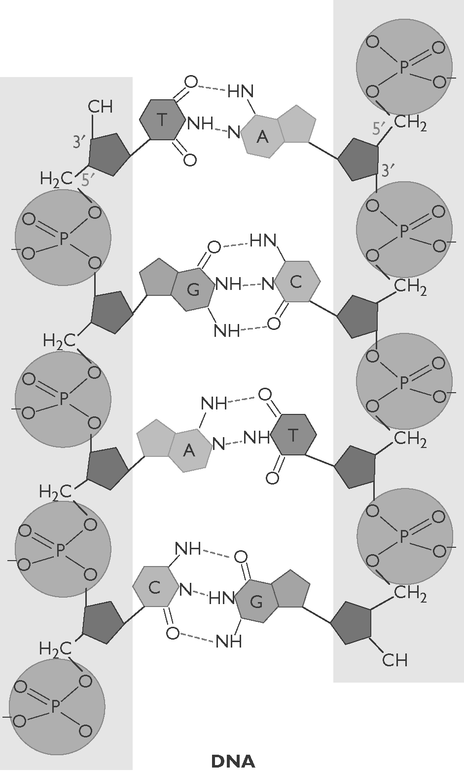 | 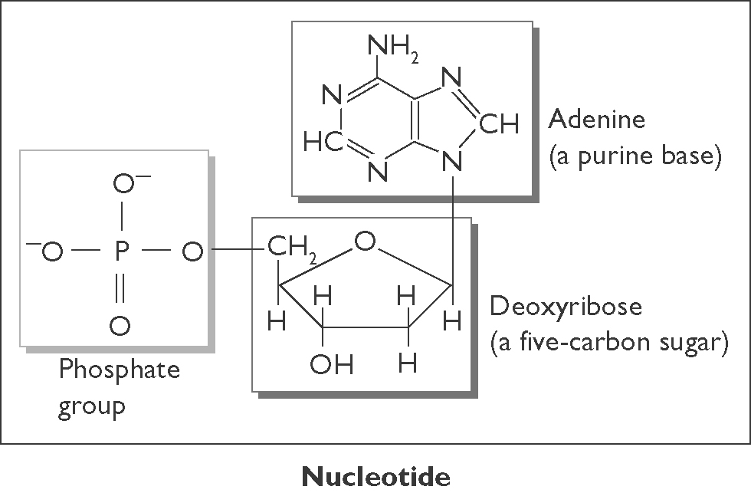  (a) Describe the structure of DNA in terms of nucleotides.  (b) Identify the molecules in the nucleotides that form the ‘backbone’ of the DNA ‘ladder’.
(c) State the pairing arrangement of the four types of nitrogen bases.

CHAPTER 2: Getting into genes
Worksheet 2.2

Page 2

Two stranded DNA
2. The following diagram is a simplified section of the double-stranded DNA molecule.
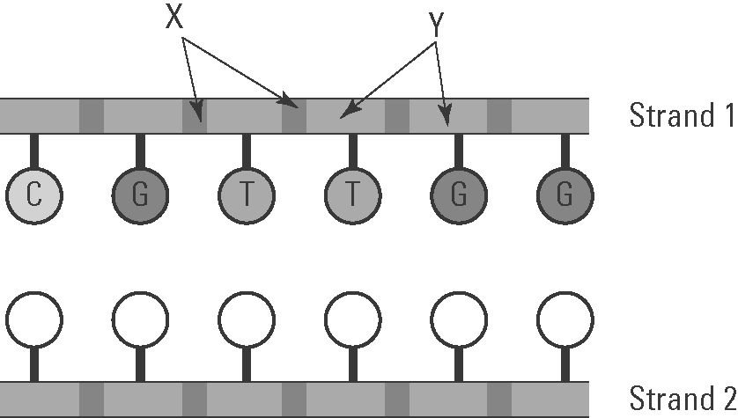 | (a) Identify components X and Y.  X: ............................................................  Y: ............................................................

(b) In strand 2 on the diagram, record the letters of the matching nitrogenous bases.

(c) What shape is a DNA molecule?

